TITLE [ALL CAPS, CALIBRI LIGHT 18PT]

SUBTITLE [IF NEEDED; ALL CAPS, CALIBRI LIGHT 14PT]
Name Surname*, scientific title; Name Surname**, scientific title [stud., PhDc., assist. PhD, lecturer PhD, assoc. prof. PhD, prof. PhD, researcher etc. followed by profession; e.g.: assoc. prof. PhD. arch.]
*Affiliation [Full name of the institution, City, Country abbreviation; e.g. University of Architecture and Urbanism „Ion Mincu”, Bucharest, RO]
email@adress.com

Abstract
Please make sure that the abstract has no more than 300 words. It must be redacted in Calibri light 10pt, justified, with no indentention. In the abstract you shoult clearly state: the purpose, methodology and main conclusions of the research.
It must not contain references. If you must refer to a certain book, article etc. please state the full name of the author, the year of publication and the title of the book/article etc.
Abstract and keywords will pe aligned at the bottom of the first page.
Keyords: keyword, keyword, keyword [please provide at least three keywords]

Section 1 [Calibri light, 14pt, bold, capitalize only first letters]
The main body will be written using Calibri light, 12pt, with no indentention, justified. You can write your text directly into this template or insert it using right clik and the command <merge formatting>. Please do not number the sections and subsections. They will be visible by using the styles sampled throughout the template: Heading 1 for sections, Heading 2 for subsections (Heading 3 if needed further). The other sampled styles are: Footnote text for footnotes, Quote for quotes that are longer than 3 lines, Caption for table and figure captions, Normal for main text, References for the references list in the end.
The first section should be introductory and at least the following should be stated:
- the purpose and objectives of the research;
- backgroud;
- a review of the main literature;
- methodology;
- limitations;
- a summary of the results.
Note that the list above constitutes the style for any lists you shall use along the text.
Please don’t leave any section without text (write at least a couple of lines before writing into subsections). The use of subsections is not mandatory.

Subsection 1.1 [Calibri light, 12pt, bold, capitalize only first letters]
The final article will have between 5 and 10 pages (images, tables etc. included). The used font will be Calibri light, with a height of 12pt, written at a distance of a single line and with a 6pt spacing after paragraph. Please make sure that you proofread the text before submitting.

Subsection 1.2 [Calibri light, 12pt, bold, capitalize only first letters]
Please don’t use subsections if you don’t have at least two for the same section.
For the citations you will use “up-up quotation marks” (Bachelard, 2003, p. 58) followed, as shown, by the reference using APA style (as in this template; more details here: https://www.bibme.org/apa). The citation will be written as in the original text (please do not write quotes in italics). If you wish to emphasize some of the words you can cite as follows “up-up quotation marks” (our emphasis, MacLeod, 2005, p. 117).
If you only wish to refer to a certain book/article without giving a citation, use (Hooper-Greenhill, 2007).
If a citation is longer that three lines, please use the Quote style – Calibri light, 10pt, left indentation 1,5cm, single spacing, 12pt spacing before and after paragraph, but don’t use too many such quotes. Try to paraphrase or break the citation with personal comments. Please note that this kind of citation dosn’t use quotation marks. (King, 2004, p. 32)
It is mandatory for the text to have at least five references and all of them to be mentioned (Murphet, 2004) in the main text (references, not bibliography – https://www.bibliography.com/how-to/apa-references-works-cited-and-bibliography-differences/).

Section 2 [Calibri light, 14pt, bold, capitalize only first letters]
The images will have a resolution of 300dpi, will be inserted into the main text where needed and with no exception will be refered to in the text as follows (Fig. 1). You must have copyright over the attached images or they will be cited respecting the copyright and the Creative Commons politics. All the images and tables will be numbered and shortly described. Images will be centered. If you use more than one image on a row please insert them into tables with as much columns as needed and make individual captions. If the images form a whole and they need a single caption please use Fig. 1a, Fig. 1b, Fig. 1c if needed.
When you place Figures please make sure that you don’t have large blank spaces till the end of the page.
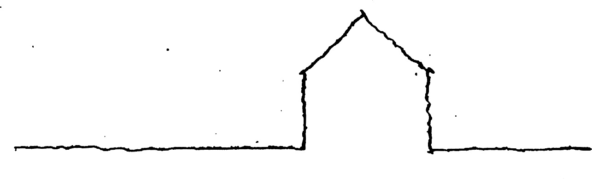
Fig. 1. We recommend inserting the images into tables to avoid displacement. The caption will be written in a different row, as sampled here (it is mandatory to write a few words about the figure). The lines of the table will be hidded in the end. All the images will be numbered as in this template and will be mentioned in the main text. Also, state the (c) and/or source of the image here.

Tables will be numbered as well (Table 1, 2 etc.) and refered to in the main text using Tab. 1 etc. You will use the same caption style as for images but please note that the caption will be placed above the table.

Conclusions
You can use as many sections and subsections as needed.
Drawing conclusions in the end is necessary. You can also add considerations about results and state further discussions.
It is recommended to return to some of the references you used in the introduction and to state your results and conclusions critically relating to the theoretical literature.
The files will be saved as Name_Surname_short title.doc or .docx and will also be sent in a .pdf format.
For generating the references section and to corectly and easily keep track of the quotations throughout the article we recommend using add-ons as zotero (APA style – American Psychological Association 7th edition). In the references section no title will be written unless it appears in the main text. The references section will include web references, mentioned according to APA style.

References
Bachelard, G. (2003). Poetica spaţiului. (I. Bădescu, Trans.). Piteşti: Paralela 45.
Hooper-Greenhill, E. (2007). Interpretive Communities, Strategies and Repertoires. In S. Watson (Ed.), Museums and their Communities. (pp. 76–94). Taylor & Francis e-Library.
King, P. (2004). Private Dwelling: Contemplating the Use of Housing. London; New York: Routledge.
Kossak, F. (2012). Productive exhibitions: looking backwards to go forward. In S. MacLeod, L. H. Hanks, & J. Hale (Eds.), Museum Making: Narratives, Architectures, Exhibitions (pp. 213–222). London and New York: Routledge.
MacLeod, S. (Ed.). (2005). Reshaping Museum Space: Architecture, Design, Exhibitions. London and New York: Taylor & Francis.
Murphet, J. (2004). Postmodernism and space. In S. Connor (Ed.), The Cambridge Companion to Postmodernism (pp. 116–135). Cambridge, UK: Cambridge University Press.

Acknowledgments. Please specify if the article is being published as the result of a financed project.
Please note that any text in light grey and square brackets shall/will be deleted. Those are only for your information.

